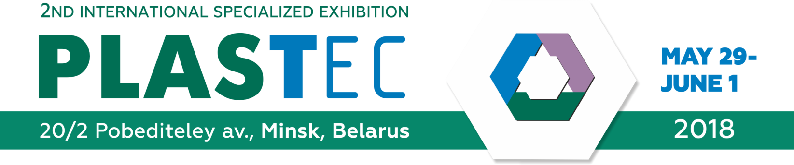

**SHORT REVIEW OF POLYMERS MARKET IN BELARUS**

The market of plastics and polymers is one of the most stable-growing and dynamically-developing in the Republic of Belarus. In spite of crises phenomena in world economy, their consumption is increasing steadily. Plastics and polymers is most important structural materials of modern technics and machines, they win over more new niches in production cutting out the traditional materials – metal, wood, textile, glass, paper, etc.

Polymers production and consumption industries in Belarus have different activities depending on kinds of polymeric products taking into account the fact that the chemical branch in Belarus is advanced as well. They produce:

- **Low Density Polyethylene (**LDPE**)**

**- Polyethylene Terephthalate (PET)**

**- PE-films**

**- PP-films**

**- PE-pipes**

**- Polyamides of different modifications, non-woven polymeric fibers**

EXPORT from Belarus: The main partners are Russia, Ukraine, and Latvia.

IMPORT to Belarus: The main products are PVC, PE, HDPE, and PP imported from the main partners from Russia, EU, Germany, Poland, and Turkey. As to situation in polymers import in Belarus, the overall scope is permanently increased, and it means that demand is increased as well.

Development prospects: By the Program of development of industrial complex of Republic of Belarus for period till 2020 is provided the main directions of development of hi-tech polymeric production, among them:

* intensification of processing of raw materials by virtue of introduction of high-end technologies
* modernization of present and creation of new chemical productions
* creation of productions of modern structural materials on the basis of organic and non-organic polymers, composites, and glass fiber
* expanding the range of the polymeric products

It is intending to develop the centers of applied sciences in the sphere of production of rubber and plastic goods.

Moreover, should be stressed that there are several plans for realization of production and using of composite materials as well as fiberglass in Belarus. Besides, there is relevant demand on modernization of the main production base in industry.

Here should be pointed the special economic area in Belarus – **Great stone** Belarusian-Chinese industrial park, which presents territorial formation with size of 80 sq. km. The park has special legal regime with guaranteeing of comfort conditions for doing business and laconically fits into offered Chinese partnership – **One Belt, One Road**. Within the frames of development of the park is created investment projects, including 7 projects on creation of polymer productions:

* 3d-printers
* Auto componentry made from plastic
* Pigments
* Plastic packaging
* Plastic and metal-plastic pipes
* Plastic toys
* Fittings made from plastic

This fact confirms the prospectivity of grow of the market of polymers in Belarus.

**Actual fields of polymers use:**

* machine-building and auto-industry
* electronics, light industry, computerized systems
* cables and wires production
* rail and other kinds of transport
* construction
* agriculture
* medicine and pharmaceutics
* household
* packaging
* furniture, interior, and décor industry
* toys and souvenirs industry
* science intensive sectors
* other branches connected with polymers consumption and usage